|  |  |  |  |  |  |  |
| --- | --- | --- | --- | --- | --- | --- |
| S.No | Name of Practical’s | Page No. | Issue Date | Submission Date | Grade | Signature |
| 01. | Recognize the physical Topologies and cabling (co-axial,OFC,UTP,STP) of a network | 1-3 | 01-11-24 |  |  |  |
| 02. | Recognition and use of various types of connectors(RJ-45,RJ-11,BNC,SCST) | 4-5 | 03-11-24 |  |  |  |
| 03. | Recognition of network device switches, HUB, Router of access point for WI-FI | 6-7 | 05-11-24 |  |  |  |
| 04. | Making of cross Cable and Straight Cable | 8-9 | 07-11-24 |  |  |  |
| 05. | Install and Configure and Network interface card in a workstation | 10-11 | 09-11-24 |  |  |  |
| 06. | Identify the IP address for a workstation and the class of the address and configure the IP address on a workstation | 12-14 | 11-11-24 |  |  |  |
| 07. | Managing user accounts in Windows and LINUX | 15-16 | 13-11-24 |  |  |  |

**PRATICAL-01**

**AIM**: Recognize the physical topology and cabling (Cabling, OFC, UTP, STP) of a network.

**TOPOLOGY:**

Network topology is the physical and logical arrangement of a network's nodes and connections. It's used to show how devices and links are connected, and how data flows through the network

* **Bus Topology**
* **Ring Topology**
* **Tree Topology**
* **Star Topology**
* **Mesh Topology**

**Network Topology:**

Network topology is the arrangement of the elements of a communication network. Network topology can be used to define or describe the arrangement of various types of telecommunication networks, including command and control radio networks, industrial fieldbusses and computer networks.

* **BUS NETWORK TOPOLOGY:**

A bus topology has a main cable that connects to devices via drop lines using taps. While simple to install, bus topologies can have difficulties with fault detection, require more cabling than some other topologies, and are susceptible to signal collisions if multiple devices transmit simultaneously.

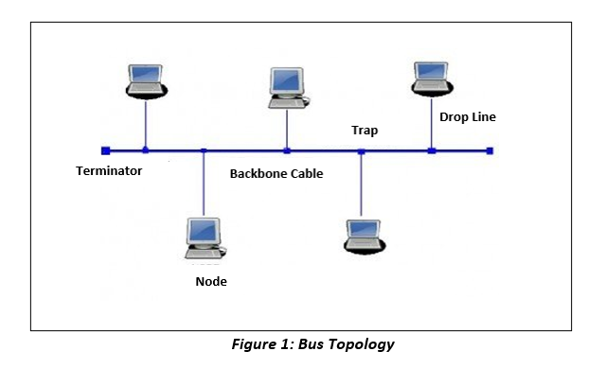

**Advantages of Bus Topology**

* It is the easiest network topology for linearly connecting peripherals or computers.
* works very efficiently well when there is a small network.

**Disadvantages of Bus Topology**

* Bus topology is not good for large networks.
* Identification of problems becomes difficult if the whole network goes down.
* **RING NETWORK TOPOLOGY:**

A ring topology is a network design where connected devices form a circular data channel. Each networked device is linked to two more ones by two points on a circle. A ring network is a collective term for the devices arranged in a ring topology

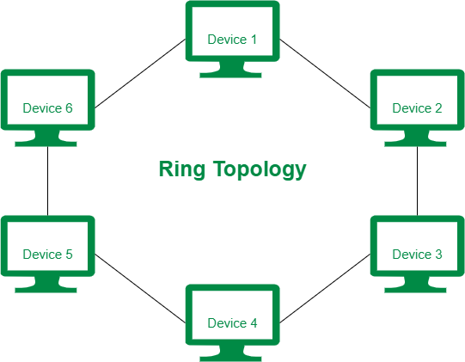

**Advantages of Ring networktopology:**

* In this data flows in one direction which reduces the chance of packet collisions.
* Equal access to the resources.

**Disadvantages of Ring networktopology:**

* Due to the Uni-directional Ring, a data packet must have to pass through all the nodes.
* If one workstation shuts down, it affects whole network or if a node goes down entire network goes down.
* **TREE NETWORK TOPOLOGY:**

Tree topology in networking refers to a hierarchical arrangement where devices are interconnected. It has a resemblance to a tree, with a central node known as the root and several offshoots called branches. The root node is linked to many tiers of child nodes, creating a hierarchical structure.

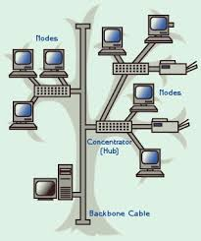

**Advantages of Tree network Topology:**

* It can support a large number of nodes.
* It can be easily expanded.

**Disadvantages of Treenetwork Topology:**

* It can be difficult to troubleshoot issues in a tree topology as each node is connected to multiple other nodes. This can make it hard to identify where the issue is located.
* Tree topology can be less reliable than other topologies such as star or mesh as there are more potential points of failure. If one node goes down, it can affect the entire network.
* **STAR NETWORK TOPOLOGY:**

A star topology is a network design where all devices are connected to a central hub or switch, and messages are passed to the central core that, in turn, passes the message to either all other systems or the specific destination system depending on the network design.

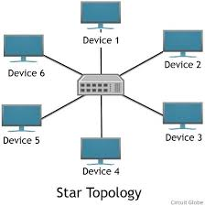

**Advantages of Star Topology:**

* It is very reliable – if one cable or device fails then all the others will still work.
* It is high-performing as no data collisions can occur.

**Disadvantages of Star Topology:**

* Requires more cable than a linear bus.
* If the connecting network device fails, the nodes attached are disabled and can’t participate in network communication.
* **MESH NETWORK TOPOLOGY:**

Mesh topology is a type of network topology where devices are interconnected to multiple other devices, forming a mesh-like structure. The devices or nodes in this topology connect dynamically, directly, and non-hierarchically to as many other nodes as possible.

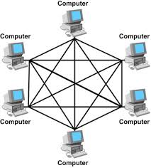

**Advantages of Mesh Topology:**

* It is very fault tolerant. If one node in the network goes down, the rest of the nodes can still communicate with each other.
* All nodes in a mesh network have a dedicated connection to every other node in the network.

**Disadvantages of Mesh Topology:**

* It can be expensive to implement because each node needs its own dedicated connection to every other node in the network.
* Mesh topology can be complex to configure and manage.

**CABLE:**

Computer cables are used to connect monitors, keyboards, printers, hard drives, and other peripherals to computers. The IEEE GlobalSpec SpecSearch database contains information about many different types of computer cables.

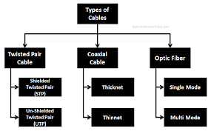

* **Coaxial:**

Coaxial cable is a type of copper cable specially built with a metal shield and other components engineered to block signal interference. A coaxial -- or coax -- cable is primarily used by cable TV companies to connect their satellite antenna facilities to customer homes and businesses.

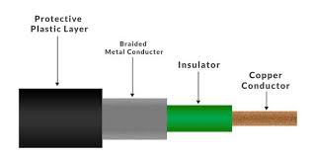

* **OFC: (Optical fiber cable)**

Optical fiber cables (OFC) are now preferred over old copper telecom cables as they provide high-speed broadband services. Optical fibre loses 3% of the signal over 100 meters of distance, while copper wires lose 94%

.

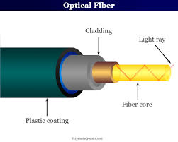

* **UTP: (Unshielded Twisted Pair cable)**

Twisted pair cabling is a type of communications cable in which two conductors of a single circuit are twisted together for the purposes of improving electromagnetic compatibility.

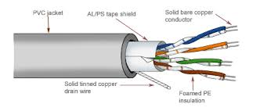

* **STP: (Shielded twisted pair)**

Shielded twisted pair (STP) is **a special kind of copper telephone and local area network (LAN) wiring used in some business installations**. It adds an outer covering or shieldsthose functions as a ground to ordinary twisted pair wiring.

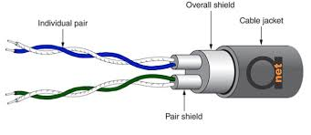

**Practical-02**

**AIM-** Recognition and use of various types of connectors RJ-45, RJ-11, BNC and SCST.

**Connectors:**

A cable connector is the component that you attach to the end of a cable so that it can plug into a port or an interface of an electronic system. The majority of connectors are either male or female gender; the males have one or more exposed pins and the female contains holes for those male pins to insert into.

**Types of connectors:**

1. RJ-45
2. RJ-11
3. BNC
4. SCST

**1. RJ-45-**

RJ45 stands for Registered Jack 45 and is the most commonly used connector in wired networks. The jacks are mainly used to connect to the Local Area Network (LAN). It was earlier devised for telephones but is now widely used in Ethernet Networking. The 45 in RJ45 basically stands for the listing number.

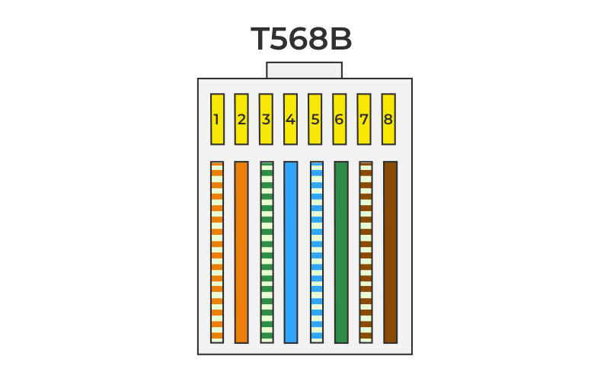

It has a color code-

* White Green
* Green
* White Orange
* Blue
* White Blue
* Orange
* White Brown
* Brown

**2. RJ-11-**

The registered jack 11 (RJ11) is a type of connector commonly used for telephone cables. It has four or

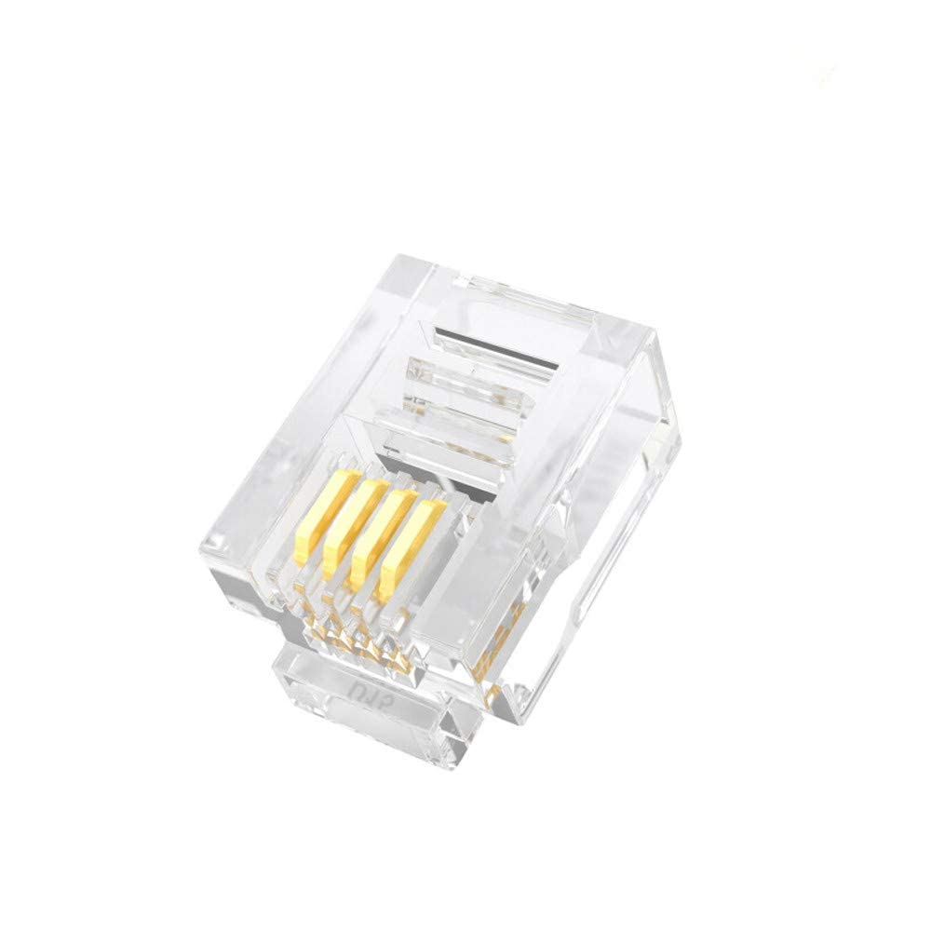Six pins and is used to connect phones, modems, and other telecommunication devices to a wall jack or other phone line.

It has a color code-

* Black
* Red
* Green
* Yellow

**3. BNC-**

Bayonet Neill–Concelman (BNC) is a type of coaxial cable connector commonly used in video and networking applications. A BNC connector works by using a rotating ring to securely connect two coaxial cables together. The inner conductor of each cable is connected to a pin, which is then inserted into the opposing connector. The rotating ring is then twisted to secure the connection.

* This type of coaxial cable connector commonly used in video and networking applications. A BNC connector works by using a rotating ring to securely connect two coaxial cables together.

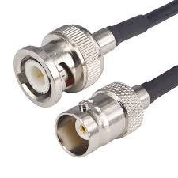

**4. SCST Connector-**

SC (Subscriber Connector) connectors, also known as square connectors or standard connectors are widely used in fiber optic networks for their excellent performance and reliability. ST (Straight Tip) connectors are another key player in the fiber optic connector arena, renowned for their reliability and durability. They were one of the first connector types widely implemented in fiber optic networking.

**SC -** Subscriber Connector.

**ST -** Straight Tip.

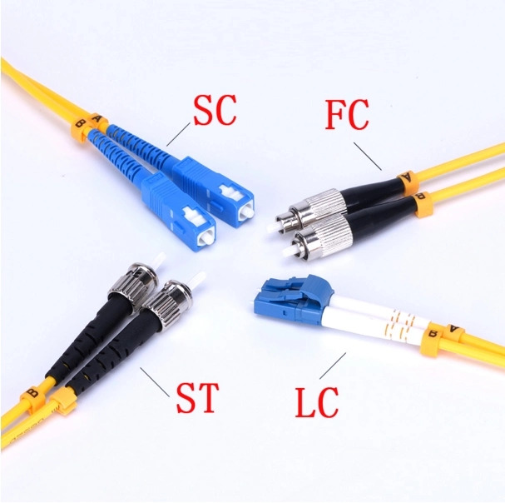

**PRACTICAL-03**

**AIM -**Recognition of network device (Switch, Hub, Router of access point for Wi-Fi):

* **Switch:**

In electrical engineering, a switch is electrical component that can disconnect or connect the conducting path in an electrical circuit, interrupting the electrical current or diverting it from one conductor to another. The most common type of switch is an electromechanical device consisting of one or more sets of movable electrical contacts connected to external circuits. When a pair of contacts is touching current can pass between them, while when the contacts are separated no current can flow.

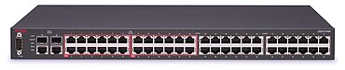

* **HUB:**

Hub is networking device that operates on the physical layer i.e. the 1st layer of the OSI model, unlike switches that operate in data link layer. Hub connects multiple devices to itself that send and receive data through it. It is a multiport repeater that comes with add-on functionalities, such as indicating any issues with the device. They come in different variants such as 4, 8, and 16 port hubs.

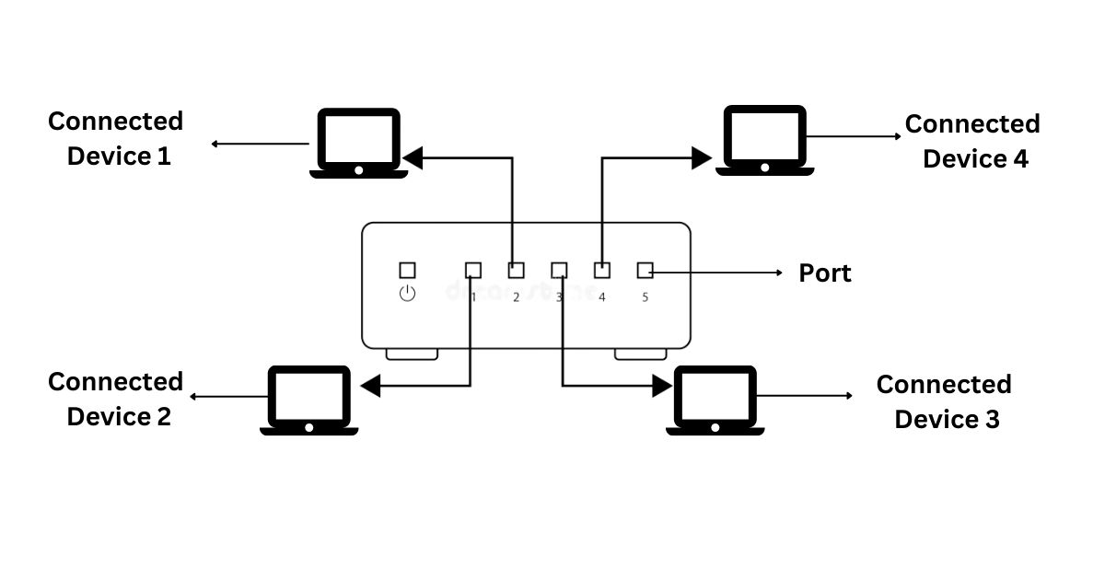

* **Router of access point for Wi-Fi:**

In an all-wireless network, an access point acts as a standalone root unit. It is not attached to a wired LAN. Instead, the access point functions as a hub that links all stations together. It serves as the focal point for communications, increasing the communication range of wireless user.

* **ROUTER:**

A router is a device that connects two or more packet-switched networks or sub networks. It serves two primary functions: managing traffic between these networks by forwarding data packets to their intended IP addresses, and allowing multiple devices to use the same Internet connection

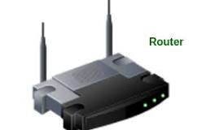

* **ACCESS POINT:**

An access point is a wireless network device that acts as a portal for devices to connect to a local area network. Access points are used for extending the wireless coverage of an existing network and for increasing the number of users that can connect to it.

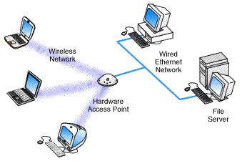

**Practical-4**

**Aim:** Making of straight cable and cross cable.

**Components required**: RJ 45 connector, climpingtool, twisted pair cable.

**Procedure**: To do these practical following steps should be done.

1.Start by stripping off about 2 inches of the plastic jacket off the end of the cable be very careful at the point, as to not nick or cut into the wires which are inside doing so could other the characteristics of the cable check the wires, one more time for Nick’s or cuts.

2.Spread the wires apart but be sure to hold onto the base of the jacket with your other hand. We don’t want the wires to be come down inside the jacket category 5 cable must only have ½ off an inch of untwisted wire at the end.

3.We have 2 end jacket which must be installed on our cable. If we are using a premade cable, with one the whacked off, we only have one end to install – the crossed over end.

**4.FOR STRAIGHT CABLE:** Now organise the cable into the correct colour order of the desired cable. We are making straight cable, which means to colour order for the wire is going to be exact same on both sides. After the colours have been organised if the all wires don’t read the same length use wire cutter directly on the end, to make each wire the same length.

5.Then, RJ 45 wire crimpnes. Will be required to hold the connector onto the cable. If the cable has got all the wire correctly insides of arty photo connector, then it should be ready to crimp the wire inside of connector. The crimpness push down a wire locking piece inside.

One of the wires is crimped down correctly the straight cable is obtained. In order to test the wire.

**FOR CROSS CABLE**:

Making a crossover Ethernet cable can be useful for connecting two devices directly, like two computers or two switches, without needing a router. Here’s a step-by-step guide:

Materials Needed:

1. Ethernet cable (CAT5e, CAT6, or similar): At least 1 meter long.
2. RJ-45 connectors: 2 pieces.
3. Crimping tool: For attaching connectors.
4. Cable stripper or scissors**: To strip the cable.
5. Cable tester (optional): To check the connection.

Steps to Make a Crossover Cable:

1. Cut the Cable to Length

- Measure and cut the Ethernet cable to your desired length.

2.Strip the Cable:

. - Use a cable stripper or scissors to carefully strip about 1 inch of the outer insulation from both ends of the cable. Be careful not to damage the inner wires.

3. Untwist and Arrange Wires

- Inside the cable, you’ll find four twisted pairs of wires (8 wires total). Untwist them and arrange them according to the T568A and T568B wiring standards. For a crossover cable, you’ll use T568A on one end and T568B on the other.

- T568A Standard (for one end):

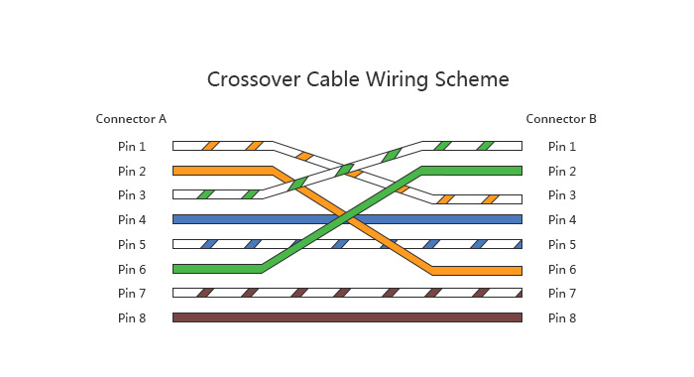 1. White/Green

2. Green

3. White/Orange

4. Blue

5. White/Blue

6. Orange

7. White/Brown

8. Brown

-T568B Standard (for the other end):

1. White/Orange

2. Orange

3. White/Green

4. Blue

5. White/Blue

6. Green

7. White/Brown

8. Brown

4. Trim the Wires

- Once arranged, trim the wires to ensure they are of equal length, leaving about 1/2 inch to fit into the RJ-45 connector.

5. Insert Wires into the RJ-45 Connector

- Hold the RJ-45 connector with the clip facing you. Carefully insert the wires into the connector, ensuring they stay in the correct order according to the standard you’re following (T568A for one end and T568B for the other). Push the wires all the way in until they reach the end of the connector.

6. Crimp the Connector

- Use the crimping tool to secure the RJ-45 connector onto the cable. Firmly squeeze the tool to ensure the metal pins pierce the wires and make a good connection.

7. Repeat for the Other End

- Follow steps 3 to 6 for the other end of the cable, making sure to use the opposite wiring standard.

8. Test the Cable (Optional):

- If you have a cable tester, use it to check the connections and ensure the cable is functioning correctly.

Conclusion:

Your crossover Ethernet cable is now ready to use! Connect the two devices directly, and you should have a network connection without any additional equipment.

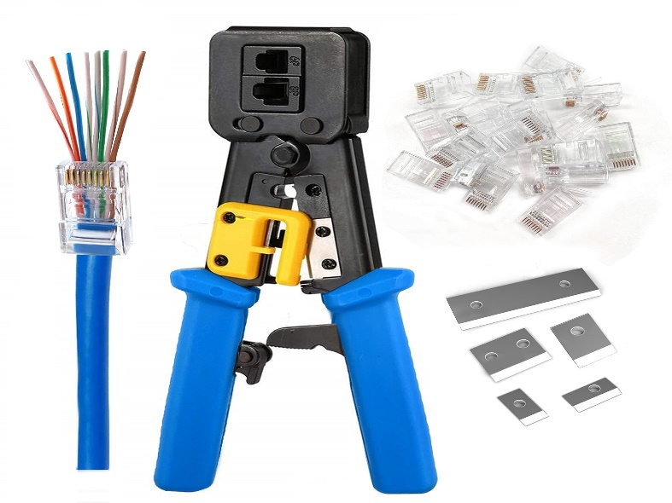

**Crimping tool**

**Practical 5**

**AIM**: Install all configure a network interface card in a workstation

**1.**Assemble the materials gather helps the network card the disc driver

**2**.Shut down windows, turn off the computer and unplug it.

**3**.Remove the cover from computer, we must typically remove a number of serous to open the screw. Put the screws at some hey won’t wander off.

**4.**Find an unused expansion slot inside the computer. The expansion slots are lined up in a second neat row near the back of the computer.

**5.**Rrmove the metal slot protector from the back of the computer chassis.

**6**.Secure the network interface card into the slot line up the connectors in the expansion slot then press the card straight down.

**7**.Secure the network interface card. Use the screws to Statics the network interface card.

**8**.Put the computer’s case back together secure the case with the screws that were removed earliest.

**9**.Plug in the computer and turn it back on.

**10**.Check if the internet works or not. If not then check the connections repeat the above steps.

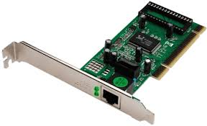

**NETWORK INTERFACE CARD**